Trent Giever

CS 140

Professor Debbie Wolf

1/31/19

Ch 5

Try it out

Steps 1-3



Steps 4-11



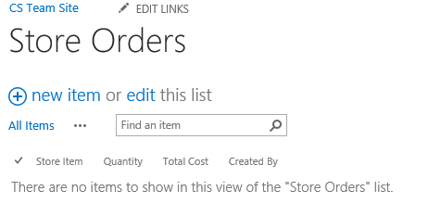

Steps 12-27



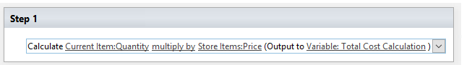

Steps 28-34

